SIMATS ENGINEERING
ASSESSMENT TOOL 1
COURSE NAME: INTERNET PROGRAMMING
COURSE CODE: CSA43

COURSE OUTCOME COVERED
CO-1: Develop well-structured, standards-compliant web pages using HTML/XHTML and XML, and apply Internet protocols and HTTP communication mechanisms for web content delivery. (L2)
Assessment Tool: Application-Based Questions
Weightage: 40%
Total Marks: 30

1. Online Symposium Portal
Given situation: A college is developing an online symposium registration portal. The form sends student details to the /register endpoint using POST.

1.1. Identify appropriate HTML5 semantic elements missing in the structure.
The original form contains input controls but lacks page-level semantic structure and accessible labels. Suitable elements include <header> for the portal heading, <main> for the primary content, <section> for the registration area, and <footer> for contact or copyright information. A <form> element is already present. Each input should have a matching <label>, and related controls may be grouped using <fieldset> and <legend>.

1.2. Modify the structure to make it standards-compliant.
The following example uses a document type, language, character encoding, viewport metadata, semantic elements, explicit labels, and required-field validation.
<!DOCTYPE html>
<html lang="en">
<head>
<meta charset="UTF-8">
<meta name="viewport" content="width=device-width, initial-scale=1.0">
<title>Symposium Registration</title>
</head>
<body>
<header>
<h1>College Symposium</h1>
</header>
<main>
<section aria-labelledby="registration-heading">
<h2 id="registration-heading">Student Registration</h2>
<form action="/register" method="post">
<label for="name">Full name:</label>
<input id="name" name="name" type="text" autocomplete="name" required>
<label for="email">Email address:</label>
<input id="email" name="email" type="email"
autocomplete="email" required>
<button type="submit">Register</button>
</form>
</section>
</main>
<footer>
<p>Contact the symposium team for assistance.</p>
</footer>
</body>
</html>

1.3. Interpret the HTTP request generated during form submission.
When the student submits the form, the browser sends a request to the server endpoint /register. The request method is POST, so the successful form controls are encoded in the request body rather than appended to the URL. With the default form encoding, the content type is application/x-www-form-urlencoded. A simplified request is shown below. The exact headers and protocol version depend on the browser and server.
POST /register HTTP/1.1
Host: example.edu
Content-Type: application/x-www-form-urlencoded
name=Anu+Kumar&email=anu%40example.com
The browser sends only controls with a name attribute that are successful and enabled. POST does not itself encrypt data; HTTPS is required to protect it in transit.

1.4. Analyze the HTTP response cycle from server to browser.
The server receives and parses the request, validates the submitted fields, checks for duplicate or invalid registrations, and stores valid data if appropriate. It then returns an HTTP status code, response headers, and a response body. For example, the server may return 201 Created with a confirmation page, or redirect the browser to a confirmation URL using a 303 See Other response. If the data is invalid, it may return 400 Bad Request or render a page explaining the errors. The browser processes the response and displays the resulting page.
HTTP/1.1 201 Created
Content-Type: text/html; charset=utf-8
<h1>Registration received</h1>
<p>Your symposium registration was submitted.</p>

1.5. Suggest improvements for usability and accessibility.
Use visible labels and clear instructions; mark required fields and explain the expected format; use appropriate input types such as email; provide keyboard-accessible controls and a visible focus indicator; ensure sufficient color contrast; show specific validation messages next to fields and announce important errors to assistive technologies; preserve entered values after validation errors; make the layout responsive for mobile devices; and provide a clear confirmation after successful registration. Validate on both the client and server, and use HTTPS.
2. Cross-Browser Compatibility Issue
Given situation: A company website renders inconsistently because its HTML contains unclosed and improperly nested elements.

2.1. Identify improper nesting and missing closing tags.
The <h1> element is not closed before the <p> element begins, the <p> element is not closed, and the outer <div> is not a semantic container. The document also omits <!DOCTYPE html>, the lang attribute, character encoding, and viewport metadata. Although browsers often attempt to repair malformed HTML, relying on automatic correction can lead to unpredictable DOM structures.

2.2. Analyze how different browsers may interpret this structure.
Modern browsers use HTML parsing rules to recover from many markup errors, but malformed markup can produce an unexpected document tree. This can affect CSS selectors, spacing, accessibility-tree output, and JavaScript that depends on particular elements. Differences may also arise from default browser styles, fonts, form controls, and unsupported CSS features. Therefore, valid markup and consistent styling are important.

2.3. Identify missing semantic elements (e.g., header, section).
A <header> can contain the company name or introductory content, <main> can identify the primary page content, and <section> can group the company introduction under a meaningful heading. A <footer> may contain copyright or contact details. Semantic elements communicate purpose to browsers, developers, search systems, and assistive technologies. A <div> remains appropriate when no more meaningful semantic element fits.

2.4. Provide a corrected W3C-compliant HTML structure.
The corrected version closes every element, uses semantic landmarks, and includes standard document metadata.
<!DOCTYPE html>
<html lang="en">
<head>
<meta charset="UTF-8">
<meta name="viewport" content="width=device-width, initial-scale=1.0">
<title>Company</title>
</head>
<body>
<header>
<h1>Welcome</h1>
</header>
<main>
<section aria-labelledby="about-heading">
<h2 id="about-heading">About Us</h2>
<p>Learn about our company, services, and values.</p>
</section>
</main>
<footer>
<p>&copy; 2026 Company</p>
</footer>
</body>
</html>

2.5. Suggest techniques to ensure cross-browser compatibility.
Use valid HTML and CSS and check the page with the W3C Markup Validation Service and CSS Validator. Declare a standards-mode doctype, set the viewport, and use a consistent CSS reset or normalization stylesheet when appropriate. Prefer widely supported standards-based features, check browser compatibility data before using newer APIs, and test in current Chrome, Firefox, Edge, and Safari at multiple screen sizes. Use responsive layouts, avoid browser-specific hacks where possible, and run automated tests for important pages.
3. Form Submission Failure
Given situation: A login form uses GET, and its button has type="button".

3.1. Identify issues in the form configuration.
The button is declared as type="button", which does not submit the form by default. The form also uses GET for a password, which is inappropriate because GET places form data in the URL query string. The fields lack labels and required validation, and the snippet does not show a secure HTTPS connection or server-side authentication handling.

3.2. Analyze why the HTTP request is not triggered.
Clicking a button with type="button" does not invoke the browser's normal form-submission behavior. Unless JavaScript explicitly handles the click and sends a request, no form request is generated. Changing the button to type="submit" enables normal form submission, subject to validation and other browser behavior.

3.3. Interpret the role of GET method in this scenario.
GET is designed primarily to retrieve a resource. Form fields are typically appended to the URL as a query string, for example /submit?username=student&password=secret. URLs may be stored in browser history, server logs, analytics systems, and referrer data, so credentials must not be sent this way. GET is also unsuitable for operations that change server state. POST is the appropriate method for sending login credentials in the request body, but POST alone does not encrypt them.

3.4. Propose a corrected implementation.
The example below uses POST, a submit button, labels, autocomplete hints, and required-field checks. The endpoint must process the credentials securely on the server.
<!DOCTYPE html>
<html lang="en">
<head>
<meta charset="UTF-8">
<meta name="viewport" content="width=device-width, initial-scale=1.0">
<title>Login</title>
</head>
<body>
<main>
<h1>Login</h1>
<form action="/submit" method="post">
<label for="username">Username:</label>
<input id="username" name="username" type="text"
autocomplete="username" required>
<label for="password">Password:</label>
<input id="password" name="password" type="password"
autocomplete="current-password" required>
<button type="submit">Login</button>
</form>
</main>
</body>
</html>

3.5. Suggest improvements for secure data transmission.
Serve the login page and endpoint only over HTTPS with a valid TLS certificate. Send credentials using POST and never place passwords in URLs. Validate input on the server, use a secure password-hashing algorithm such as Argon2id or bcrypt for stored passwords, and compare credentials safely. Apply rate limiting and appropriate protections against automated login attempts, use secure session cookies (Secure, HttpOnly, and an appropriate SameSite setting), avoid exposing detailed authentication errors, and never log passwords. Client-side validation improves usability but cannot replace server-side validation.
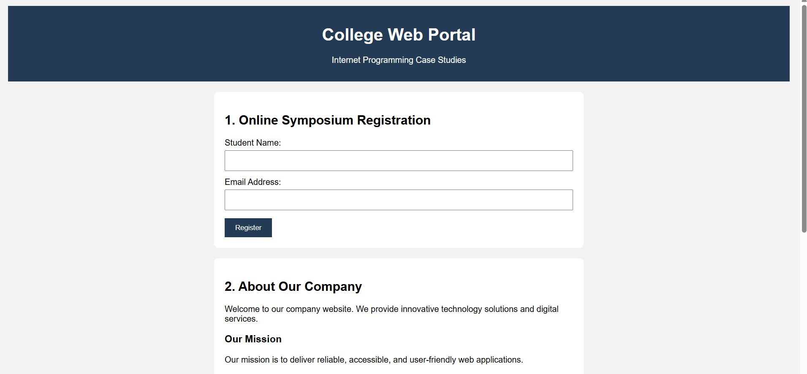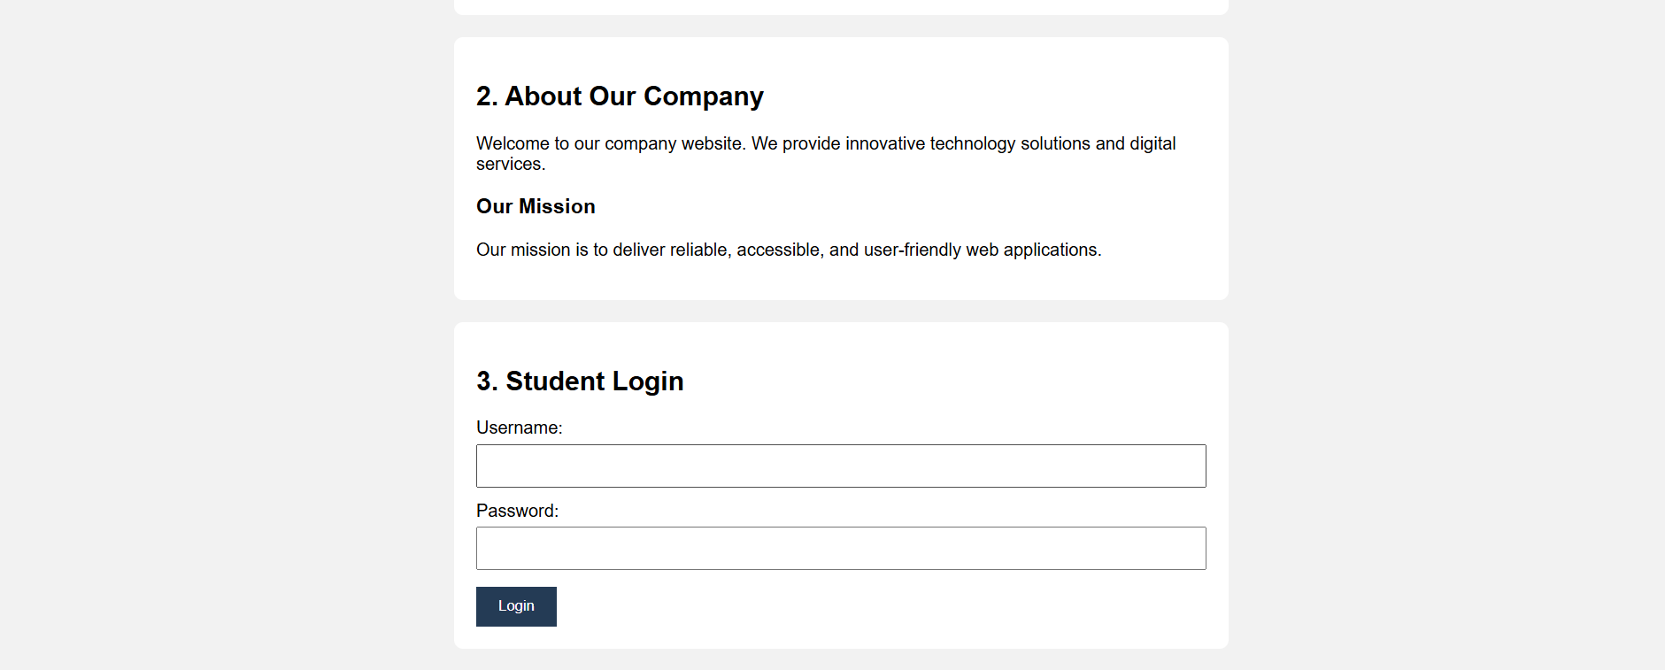

Code of Conduct
I Venkateswarlu(192411239) (Name / Reg No.) certify that this submission is my original work and that I have adhered to the guidelines specified for this assessment. I understand that any violation of academic integrity rules will result in disciplinary action.
Signature of the student:


Rubrics for Calculation
Criteria | Weightage | Level 4 – Exemplary | Level 3 – Proficient | Level 2 – Developing | Level 1 – Beginning
Understanding of Concepts | 25% | Thorough, accurate understanding of concepts. | Good understanding with minor gaps. | Basic understanding with some misconceptions. | Poor understanding; major misconceptions.
Explanation | 25% | Detailed answers with relevant examples. | Clear explanation with adequate details. | Limited explanation; lacks depth. | Poor or unclear explanation.
Application | 20% | Effectively applies concepts with strong analysis. | Applies concepts with minor errors. | Limited application and weak analysis. | No application or incorrect analysis.
Organization | 15% | Well-structured answers with logical flow. | Organized with minor flow issues. | Basic structure; lacks clarity. | Poor organization; incoherent answers.
Accuracy | 10% | Accurate and covers all required points. | Mostly accurate with minor omissions. | Partially correct with missing points. | Incorrect answers with major gaps.
Clarity | 5% | Clear, neat, professional presentation. | Understandable with minor issues. | Limited clarity and readability. | Poorly written and difficult to understand.

